Name: Vishal S. Salvi

UID:2019230069

Batch - C

# CEL 51, DCCN, Monsoon 2020

# Lab 7: RIPv2 Router Configuration

## Topology Diagram

## 

## Addressing Table

| **Device** | **Interface** | **IP Address** | **Subnet Mask** | **Default Gateway** |
| --- | --- | --- | --- | --- |
| **R1** | **Fa0/0** | 172.30.1.1 | 255.255.255.0 | N/A |
| **Fa0/1** | 172.30.2.1 | 255.255.255.0 | N/A |
| **S0/0/0** | 209.165.200.230 | 255.255.255.252 | N/A |
| **R2** | **Fa0/0** | 10.1.0.1 | 255.255.0.0 | N/A |
| **S0/0/0** | 209.165.200.229 | 255.255.255.252 | N/A |
| **S0/0/1** | 209.165.200.233 | 255.255.255.252 | N/A |
| **R3** | **Fa0/0** | 172.30.100.1 | 255.255.255.0 | N/A |
| **S0/0/1** | 209.165.200.234 | 255.255.255.252 | N/A |
| **Lo0** | 172.30.110.1 | 255.255.255.0 | N/A |
| **Lo1** | 172.30.200.17 | 255.255.255.240 | N/A |
| **Lo2** | 172.30.200.33 | 255.255.255.240 | N/A |
| **PC1** | **NIC** | 172.30.1.10 | 255.255.255.0 | 172.30.2.1 |
| **PC2** | **NIC** | 172.30.2.10 | 255.255.255.0 | 172.30.1.1 |
| **PC3** | **NIC** | 10.1.0.10 | 255.255.0.0 | 10.1.0.1 |
| **PC4** | **NIC** | 172.30.100.10 | 255.255.255.0 | 172.30.100.1 |

## Learning Objectives

Upon completion of this lab, you will be able to:

* Cable a network according to the Topology Diagram.
* Load provided scripts onto the routers.
* Examine the current status of the network.
* Configure RIPv2 on all routers.
* Examine the automatic summarization of routes.
* Examine routing updates with **debug ip rip**.
* Disable automatic summarization.
* Examine the routing tables.
* Verify network connectivity.
* Document the RIPv2 configuration.

## Scenario

The network shown in the Topology Diagram contains a discontiguous network, 172.30.0.0. This network has been subnetted using VLSM. The 172.30.0.0 subnets are physically and logically divided by at least one other classful or major network, in this case the two serial networks 209.165.200.228/30 and 209.165.200.232/30. This can be an issue when the routing protocol used does not include enough information to distinguish the individual subnets. RIPv2 is a classless routing protocol that can be used to provide subnet mask information in the routing updates. This will allow VLSM subnet information to be propagated throughout the network.

Task 1: Cable, Erase, and Reload the Routers.

Step 1: Cable a network.

Cable a network that is similar to the one in the Topology Diagram.

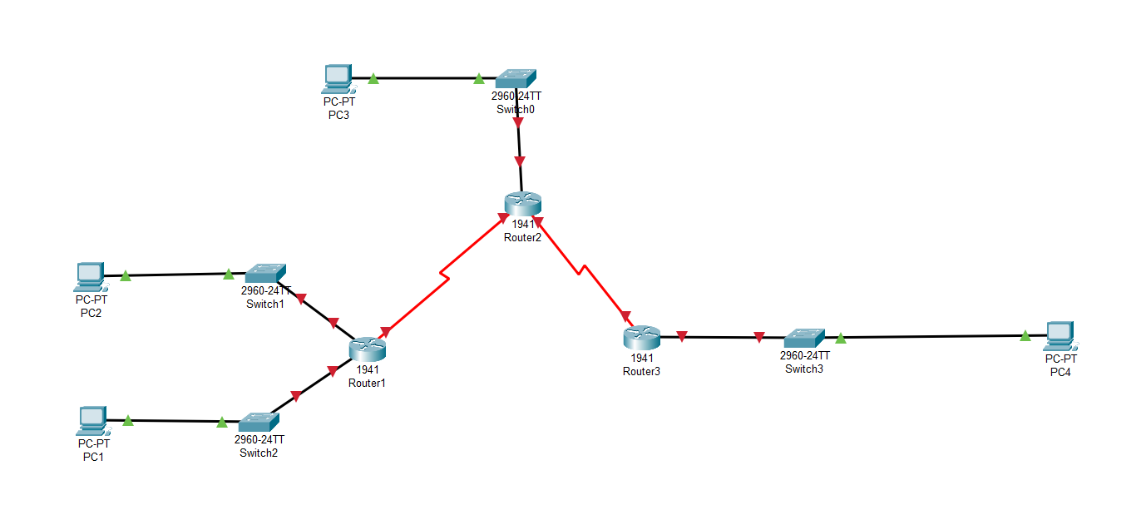

Step 2: Clear the configuration on each router.

Clear the configuration on each of routers using the **erase startup-config** command and then **reload** the routers. Answer **no** if asked to save changes.

Router1

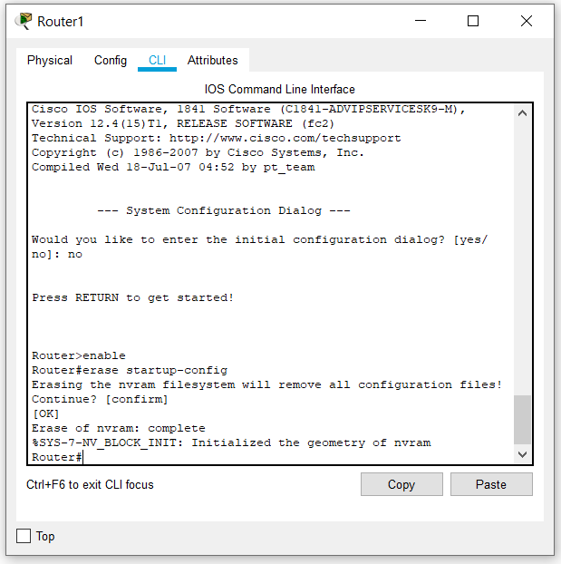

Router 2

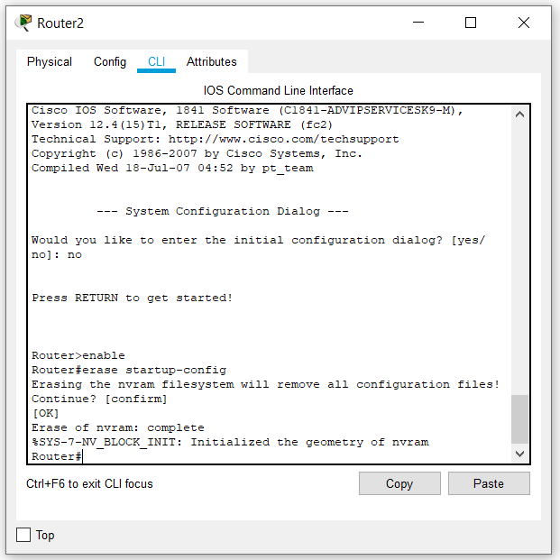

Router 3

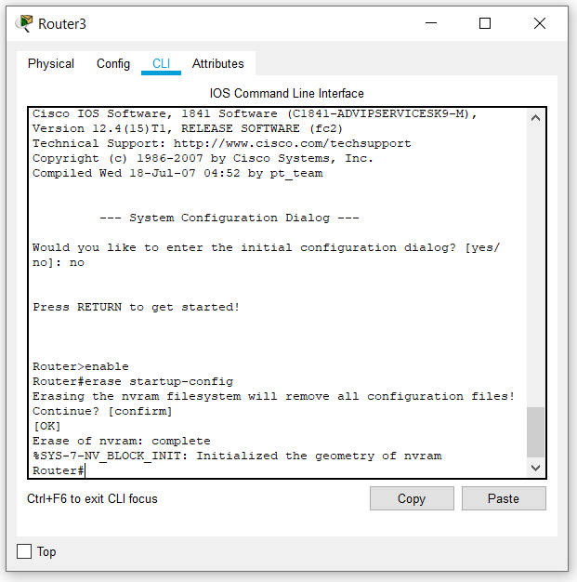

Task 2: Load Routers with the Supplied Scripts.

Step 1: Load the following script onto R1.

!

hostname R1

!

!

!

interface FastEthernet0/0

ip address 172.30.1.1 255.255.255.0

duplex auto

speed auto

no shutdown

!

interface FastEthernet0/1

ip address 172.30.2.1 255.255.255.0

duplex auto

speed auto

no shutdown

!

interface Serial0/0/0

ip address 209.165.200.230 255.255.255.252

clock rate 64000

no shutdown

!

router rip

passive-interface FastEthernet0/0

passive-interface FastEthernet0/1

network 172.30.0.0

network 209.165.200.0

!

line con 0

line vty 0 4

login

!

End

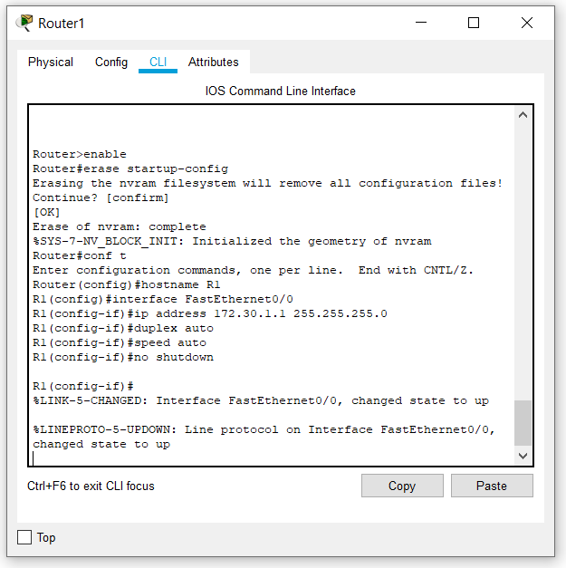

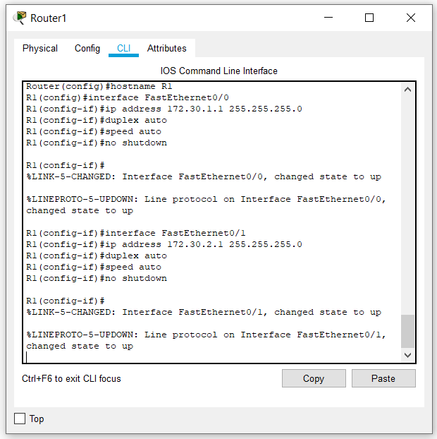

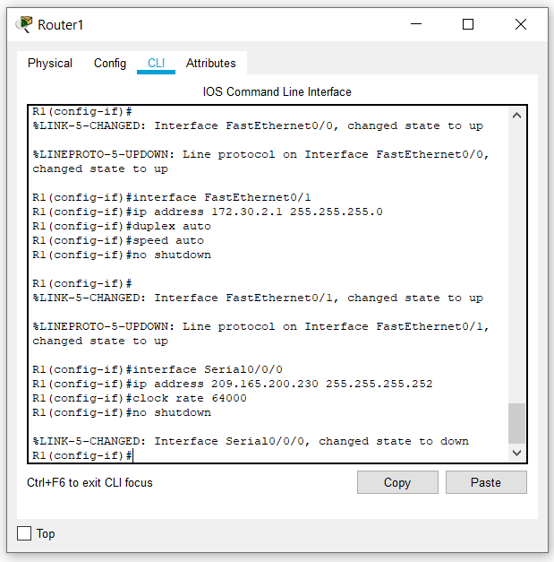

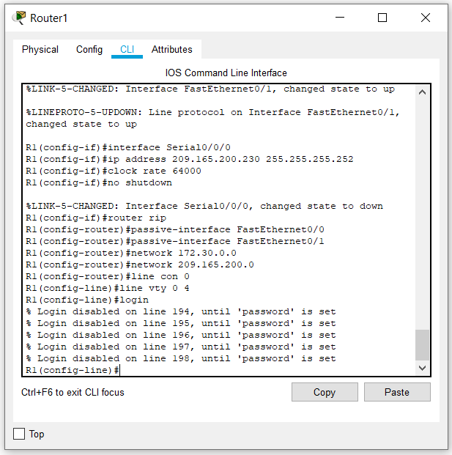

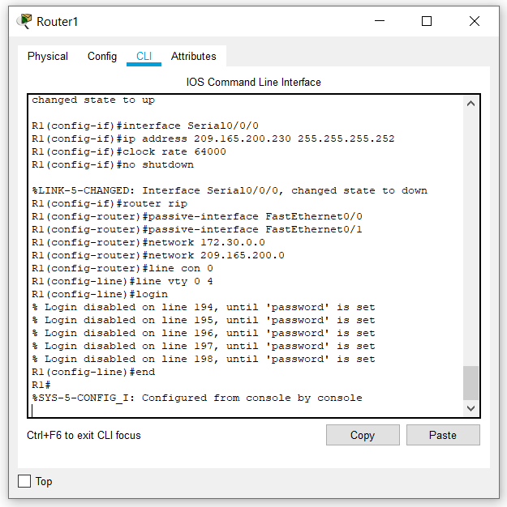

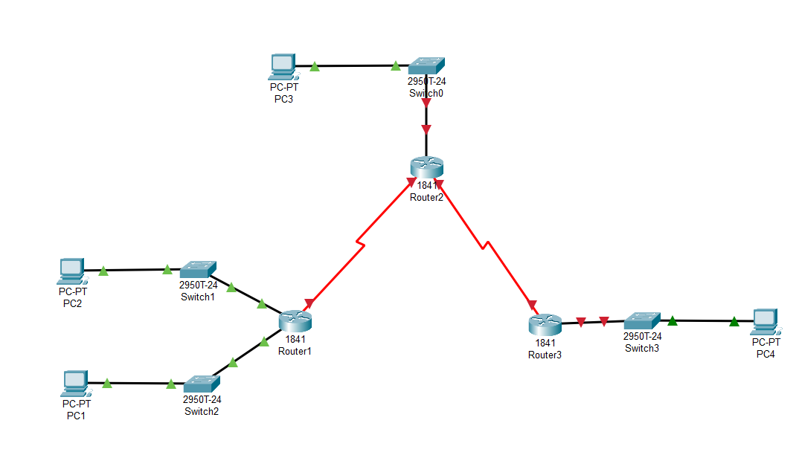

Step 2: Load the following script onto R2.

hostname R2

!

!

!

interface FastEthernet0/0

ip address 10.1.0.1 255.255.0.0

duplex auto

speed auto

no shutdown

!

interface Serial0/0/0

ip address 209.165.200.229 255.255.255.252

no shutdown

!

interface Serial0/0/1

ip address 209.165.200.233 255.255.255.252

clock rate 64000

no shutdown

!

router rip

passive-interface FastEthernet0/0

network 10.0.0.0

network 209.165.200.0

!

line con 0

line vty 0 4

login

!

end

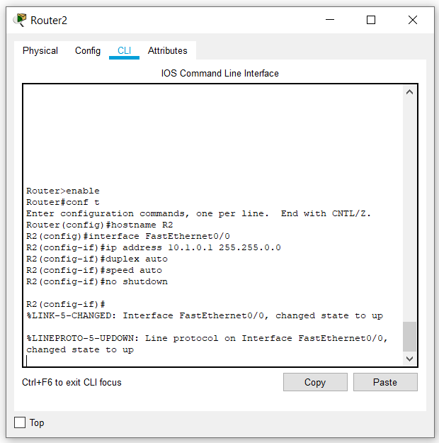

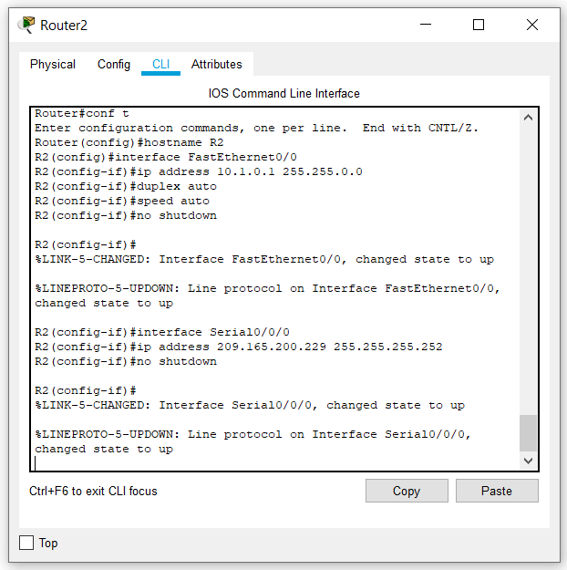

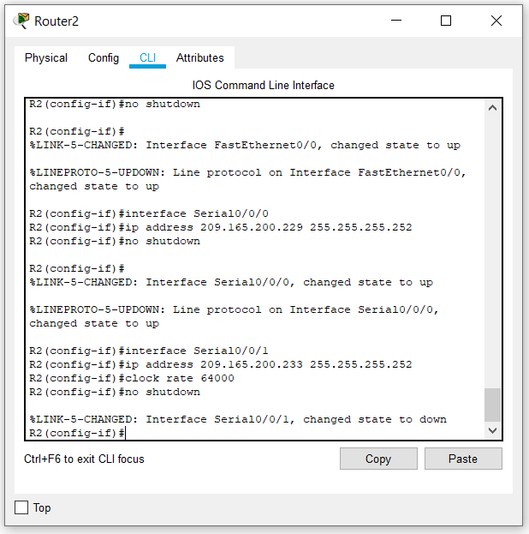

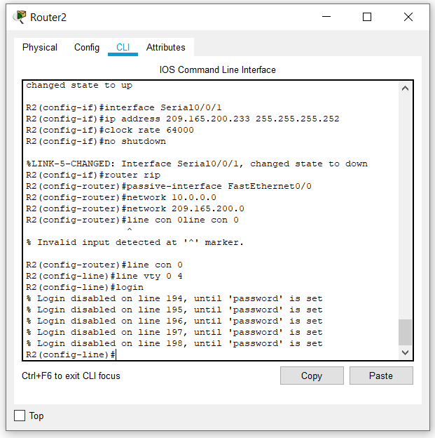

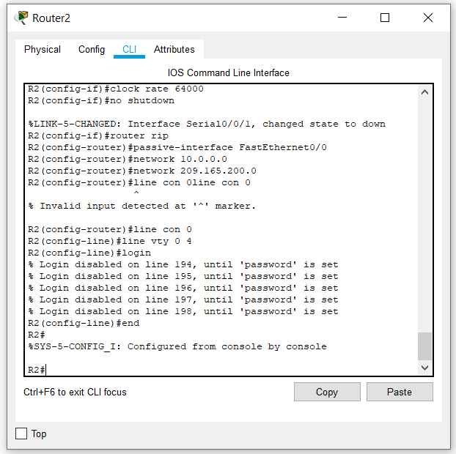

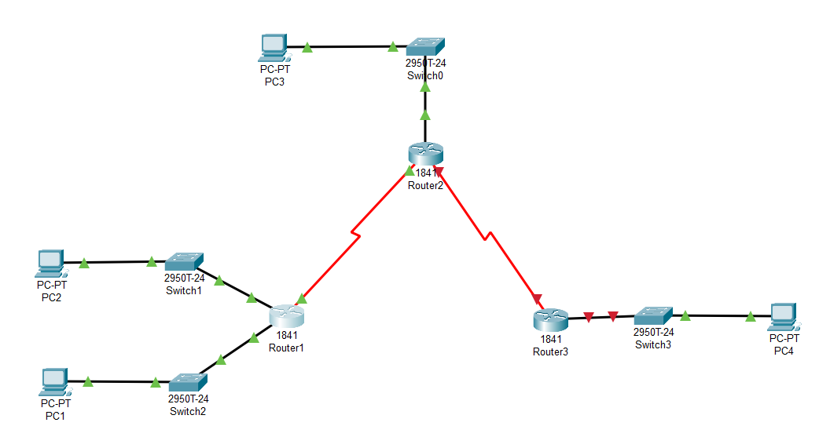

Step 3: Load the following script onto R3.

hostname R3

!

!

!

interface FastEthernet0/0

ip address 172.30.100.1 255.255.255.0

duplex auto

speed auto

no shutdown

!

interface Serial0/0/1

ip address 209.165.200.234 255.255.255.252

no shutdown

!

interface Loopback0

ip address 172.30.110.1 255.255.255.0

!

interface Loopback1

ip address 172.30.200.17 255.255.255.240

!

interface Loopback2

ip address 172.30.200.33 255.255.255.240

!

router rip

passive-interface FastEthernet0/0

network 172.30.0.0

network 209.165.200.0

!

line con 0

line vty 0 4

login

!

end

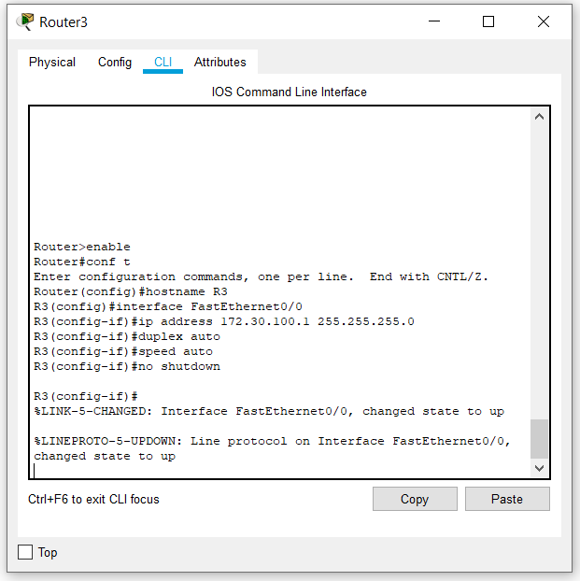

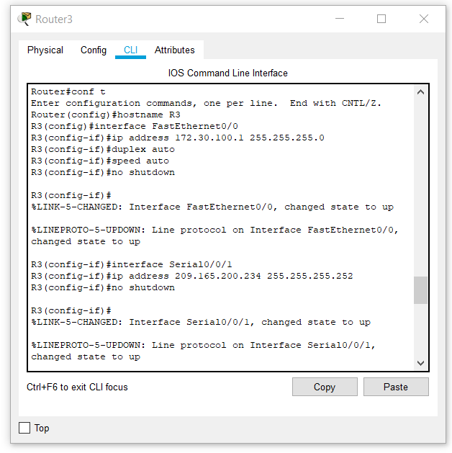

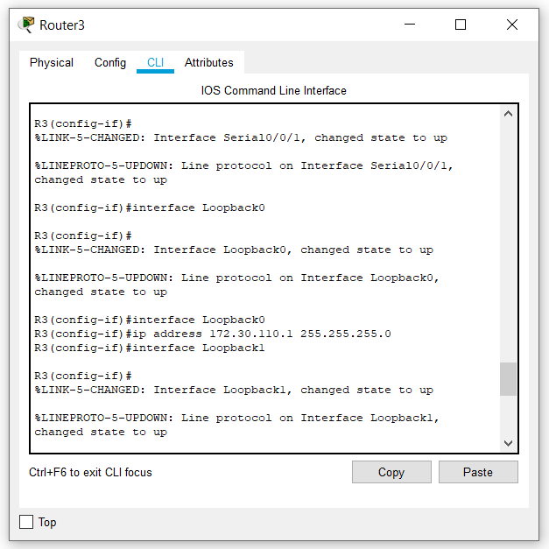

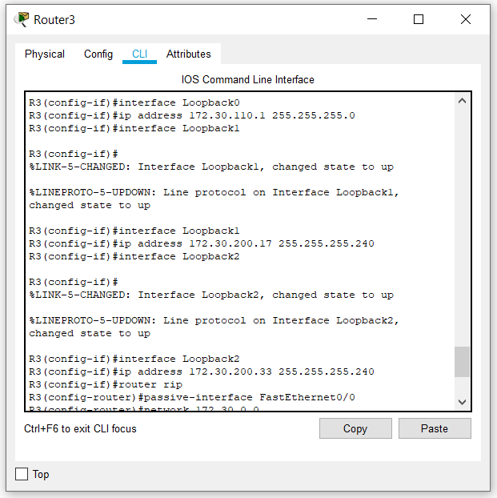

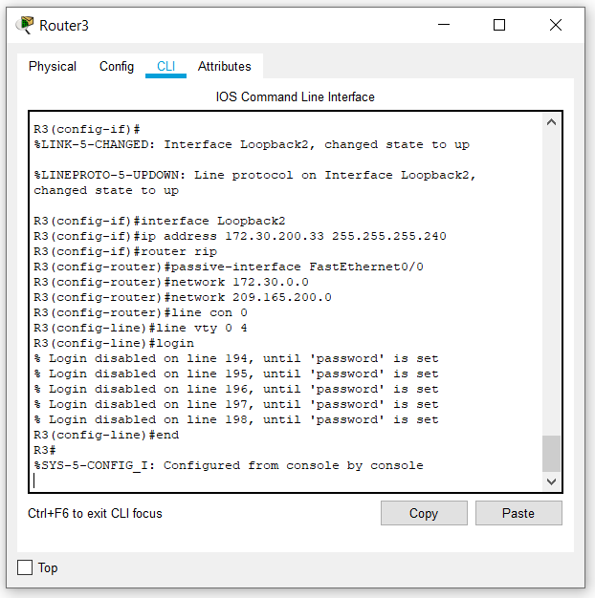

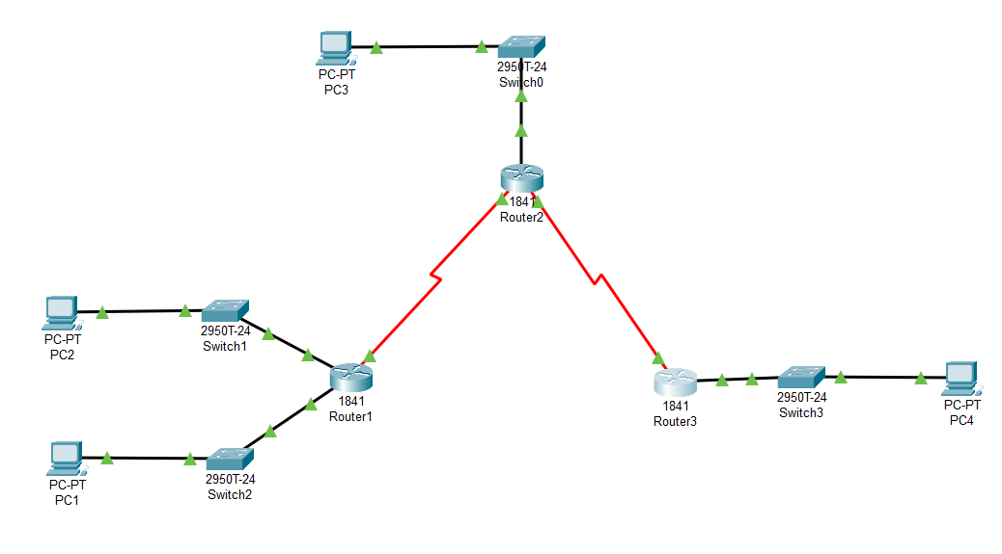

Task 3: Examine the Current Status of the Network.

Step 1: Verify that both serial links are up.

The two serial links can quickly be verified using the **show ip interface brief** command on R2.

R2#**show ip interface brief**

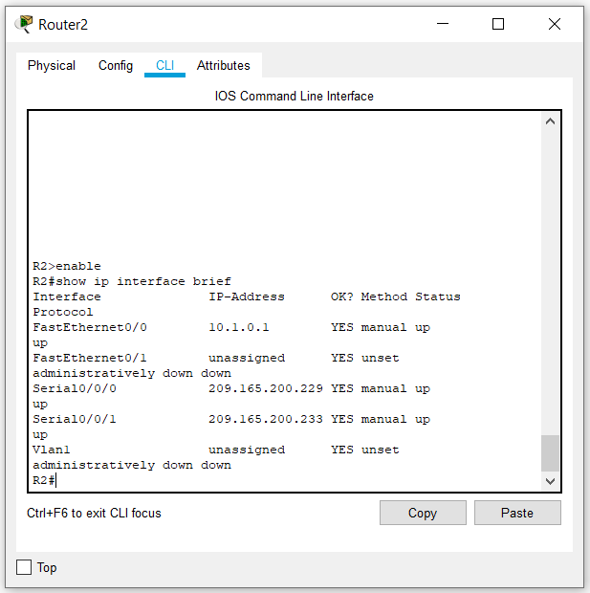

Step 2: Check the connectivity from R2 to the hosts on the R1 and R3 LANs.

Note: For the 1841 router, you will need to disable IP CEF to obtain the correct output from the **ping** command. Although a discussion of IP CEF is beyond the scope of this course, you may disable IP CEF by using the following command in global configuration mode:

R2(config)#**no ip cef**

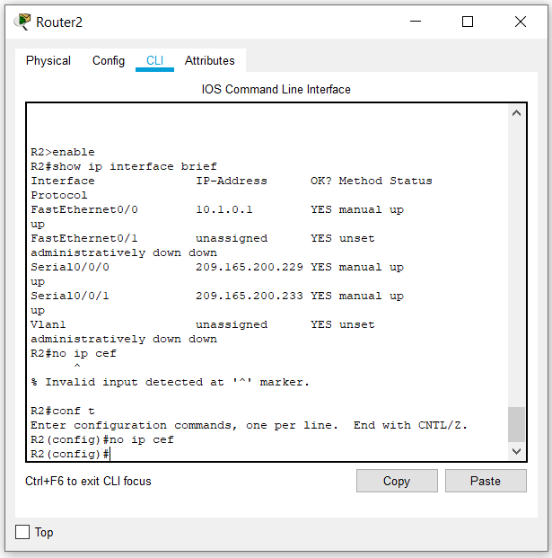

From the R2 router, how many ICMP messages are successful when pinging PC1?

5/5 100%

From the R2 router, how many ICMP messages are successful when pinging PC4?

5/5 100%

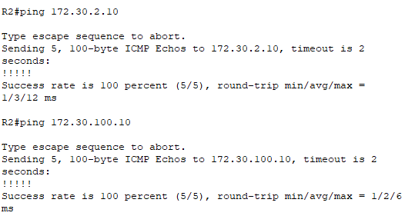

Step 3: Check the connectivity between the PCs.

From the PC1, is it possible to ping PC2? YES

What is the success rate? 4/4 100%

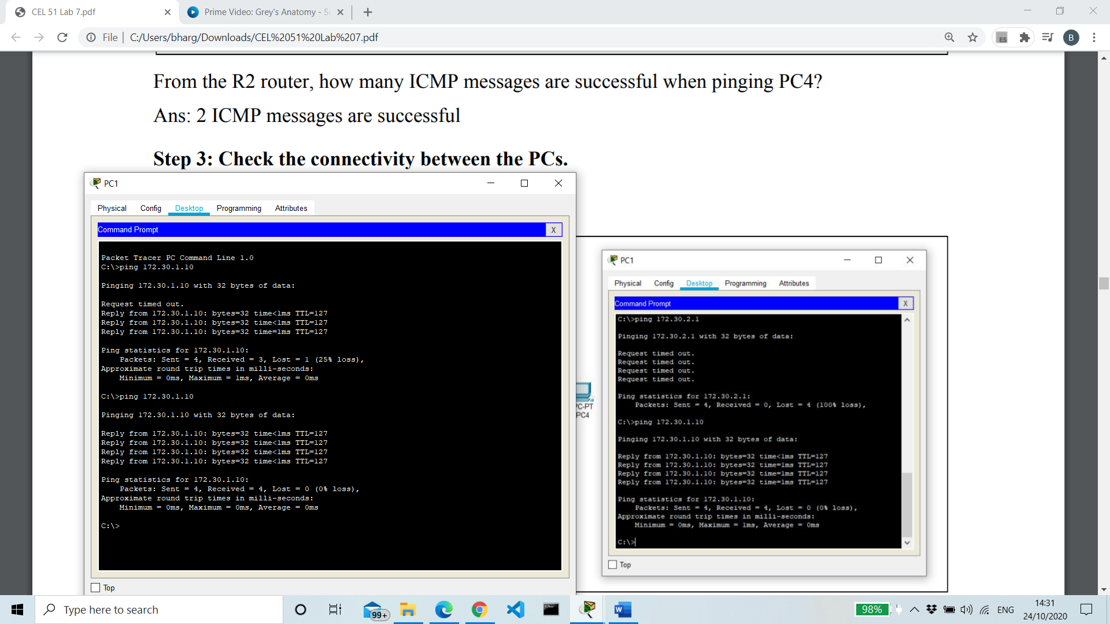

From the PC1, is it possible to ping PC3? YES

What is the success rate? 3/4 75%

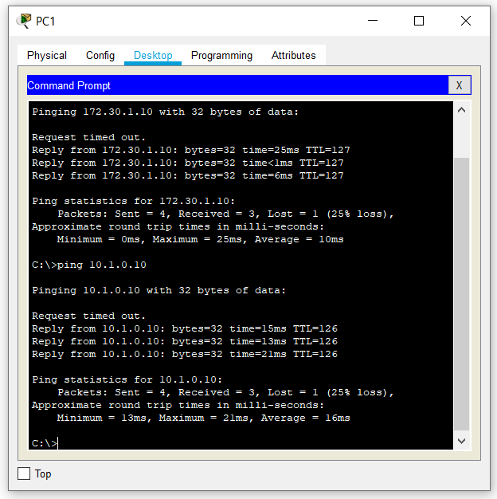

From the PC1, is it possible to ping PC4? Yes

What is the success rate? 0/4 0%

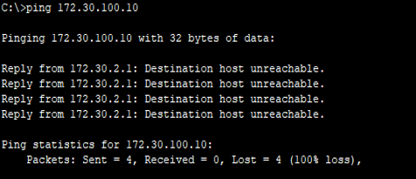

From the PC4, is it possible to ping PC2? No

What is the success rate? 0/4 0%

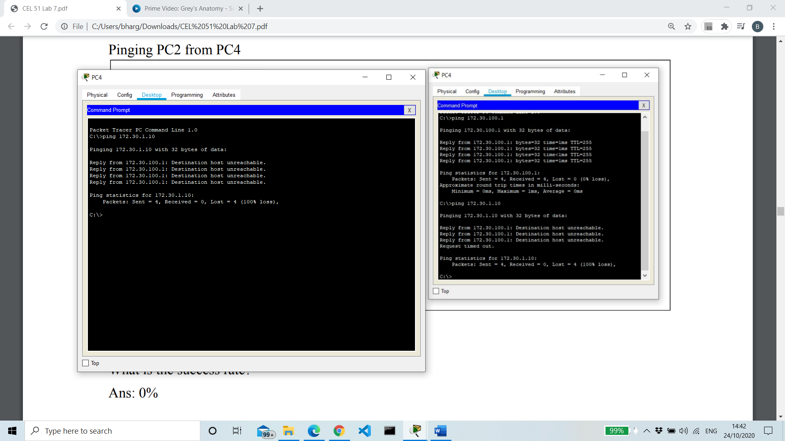

From the PC4, is it possible to ping PC3? YES

What is the success rate? 100%

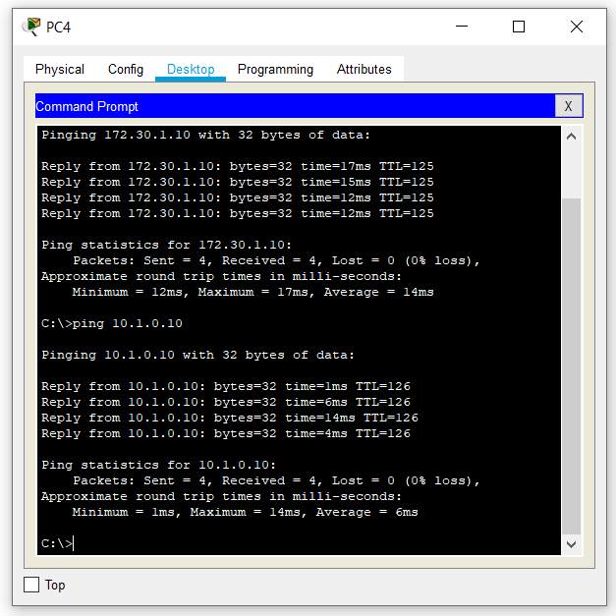

Step 4: View the routing table on R2.

Both the R1 and R3 are advertising routes to the 172.30.0.0/16 network; therefore, there are two entries for this network in the R2 routing table. The R2 routing table only shows the major classful network address of 172.30.0.0—it does not show any of the subnets for this network that are used on the LANs attached to R1 and R3. Because the routing metric is the same for both entries, the router alternates the routes that are used when forwarding packets that are destined for the 172.30.0.0/16 network.

R2#**show ip route**

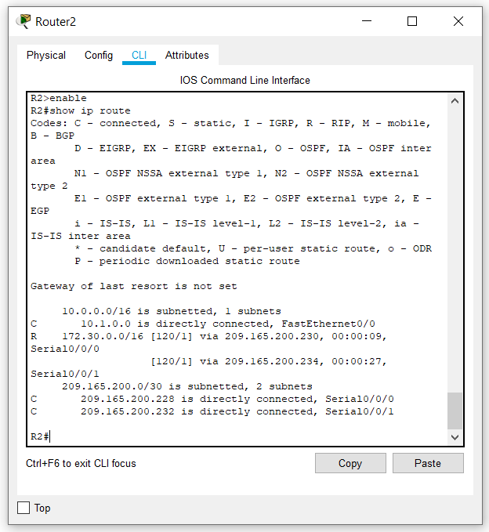

Step 5: Examine the routing table on the R1 router.

Both R1 and R3 are configured with interfaces on a discontiguous network, 172.30.0.0. The 172.30.0.0 subnets are physically and logically divided by at least one other classful or major network—in this case, the two serial networks 209.165.200.228/30 and 209.165.200.232/30. Classful routing protocols like RIPv1 summarize networks at major network boundaries. Both R1 and R3 will be summarizing 172.30.0.0/24 subnets to 172.30.0.0/16. Because the route to 172.30.0.0/16 is directly connected, and because R1 does not have any specific routes for the 172.30.0.0 subnets on R3, packets destined for the R3 LANs will not be forwarded properly.

R1#**show ip route**

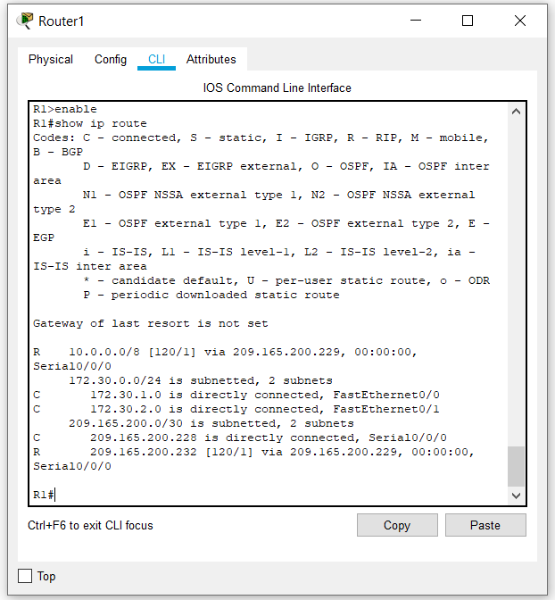

Step 6: Examine the routing table on the R3 router.

R3 only shows its own subnets for 172.30.0.0 network: 172.30.100/24, 172.30.110/24, 172.30.200.16/28, and 172.30.200.32/28. R3 does not have any routes for the 172.30.0.0 subnets on R1.

R3#**show ip route**

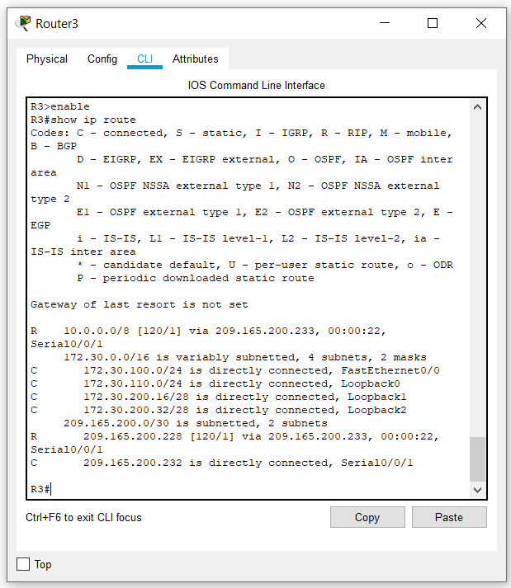

Step 7: Examine the RIPv1 packets that are being received by R2.

Use the **debug ip rip** command to display RIP routing updates.

R2 is receiving the route 172.30.0.0, with 1 hop, from both R1 and R3. Because these are equal cost metrics, both routes are added to the R2 routing table. Because RIPv1 is a classful routing protocol, no subnet mask information is sent in the update.

R2#**debug ip rip**

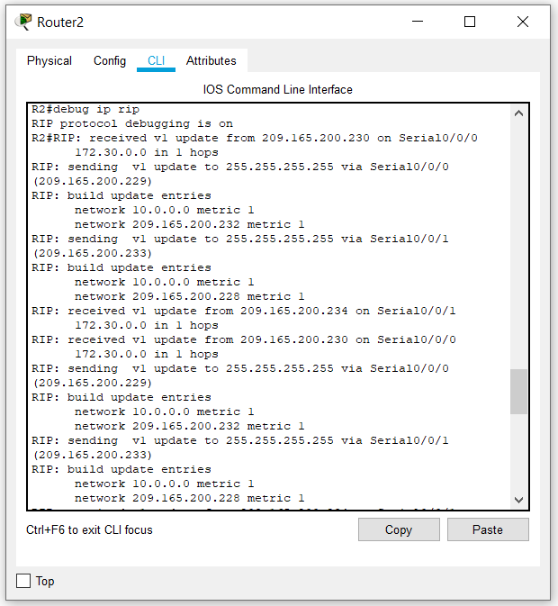

R2 is sending only the routes for the 10.0.0.0 LAN and the two serial connections to R1 and R3. R1 and R3 are not receiving any information about the 172.30.0.0 subnet routes.

When you are finished, turn off the debugging.

R2#**undebug all**

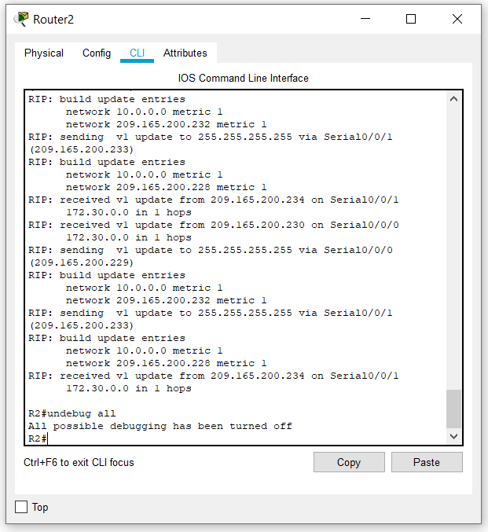

Task 4: Configure RIP Version 2.

Step 1: Use the version 2 command to enable RIP version 2 on each of the routers.

R2(config)#**router rip**

R2(config-router)#**version 2**

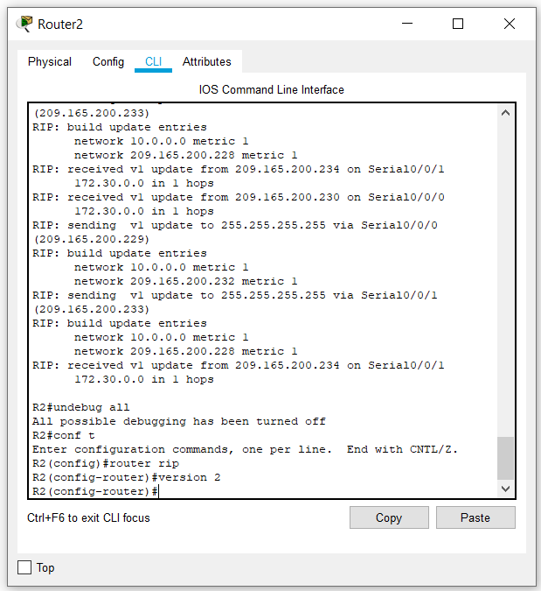

R1(config)#**router rip**

R1(config-router)#**version 2**

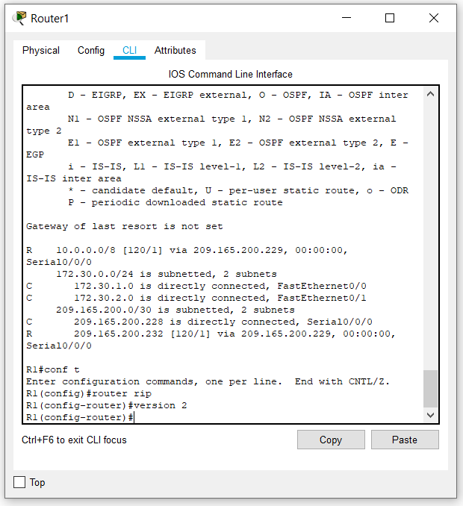

R3(config)#**router rip**

R3(config-router)#**version 2**

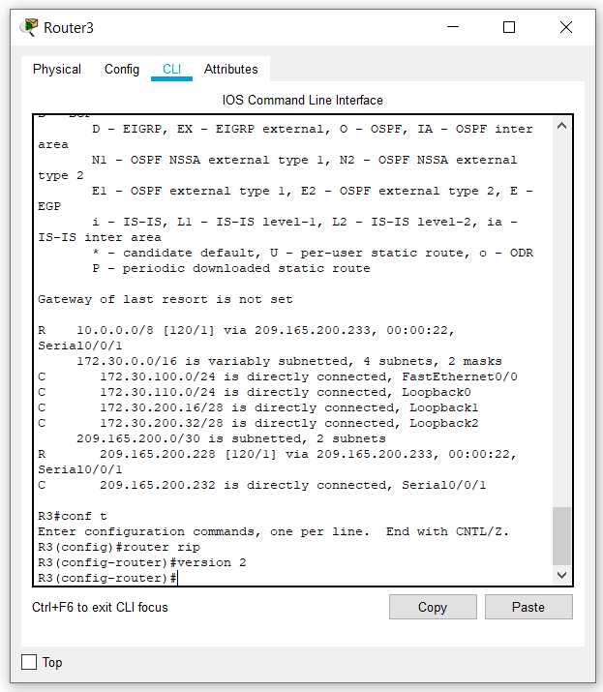

RIPv2 messages include the subnet mask in a field in the routing updates. This allows subnets and their masks to be included in the routing updates. However, by default RIPv2 summarizes networks at major network boundaries, just like RIPv1, except that the subnet mask is included in the update.

Step 2: Verify that RIPv2 is running on the routers.

The **debug** **ip rip**, **show ip protocols**, and **show run** commands can all be used to confirm that RIPv2 is running. The output of the **show ip protocols** command for R1 is shown below.

R1# **show ip protocols**

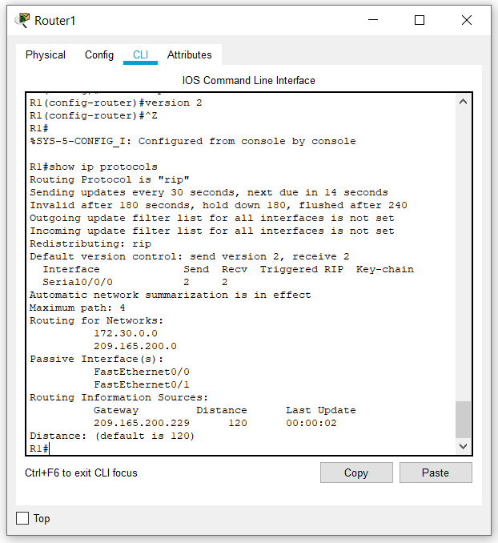

Task 5: Examine the Automatic Summarization of Routes.

The LANs connected to R1 and R3 are still composed of discontiguous networks. R2 still shows two equal cost paths to the 172.30.0.0/16 network in the routing table. R2 still shows only the major classful network address of 172.30.0.0 and does not show any of the subnets for this network.

R2#**show ip route**

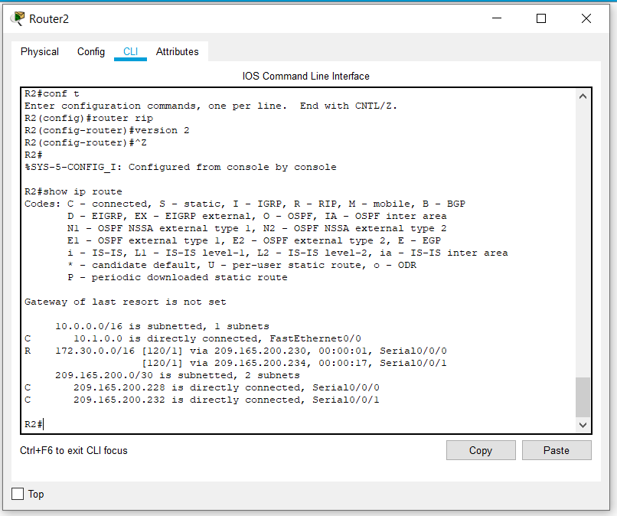

R1 still shows only its own subnets for the 172.30.0.0 network. R1 still does not have any routes for the 172.30.0.0 subnets on R3.

R1#**show ip route**

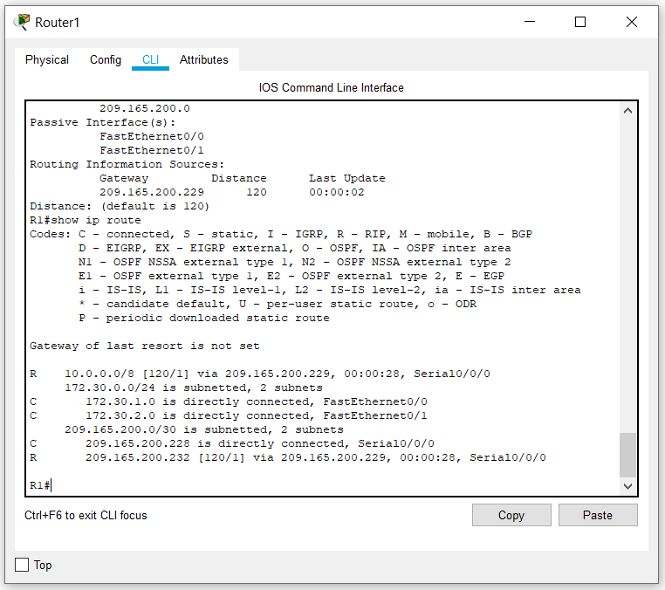

R3 still only shows its own subnets for the 172.30.0.0 network. R3 still does not have any routes for the 172.30.0.0 subnets on R1.

R3#**show ip route**

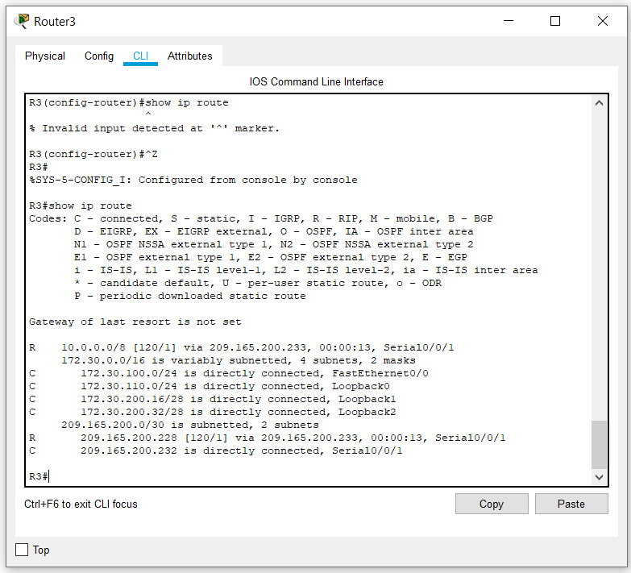

Use the output of the **debug ip rip** command to answer the following questions:

What entries are included in the RIP updates sent out from R3?

**10.0.0.0/8 via 0.0.0.0, metric 2, tag 0**

**172.30.100.0/24 via 0.0.0.0, metric 1, tag 0**

**172.30.200.16/28 via 0.0.0.0, metric 1, tag 0**

**172.30.200.32/28 via 0.0.0.0, metric 1, tag 0**

**209.165.200.0/24 via 0.0.0.0, metric 1, tag 0**

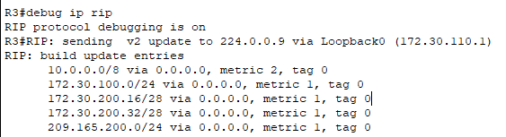

On R2, what routes are in the RIP updates that are received from R3?

**172.30.0.0/16**

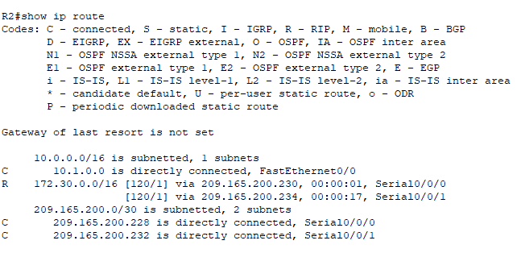

R3 is not sending any of the 172.30.0.0 subnets—only the summarized route of 172.30.0.0/16, including the subnet mask. This is why R2 and R1 are not seeing the 172.30.0.0 subnets on R3.

Task 6: Disable Automatic Summarization.

The **no auto-summary** command is used to turn off automatic summarization in RIPv2. Disable auto summarization on all routers. The routers will no longer summarize routes at major network boundaries.

R2(config)#**router rip**

R2(config-router)#**no auto-summary**

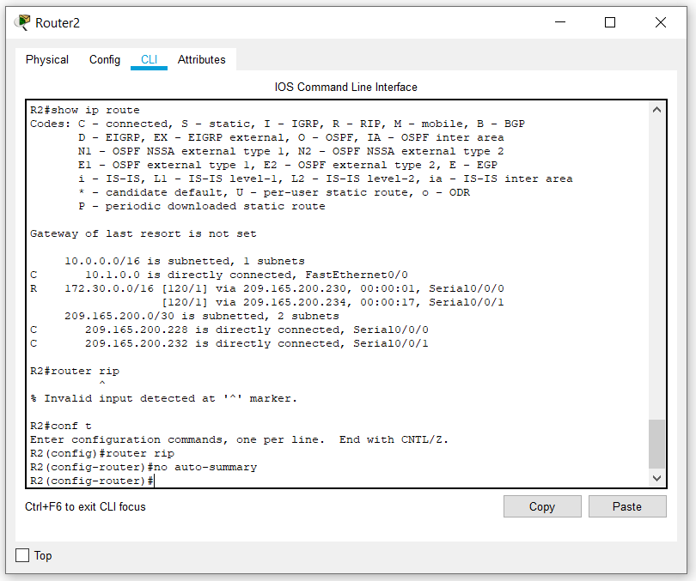

R1(config)#**router rip**

R1(config-router)#**no auto-summary**

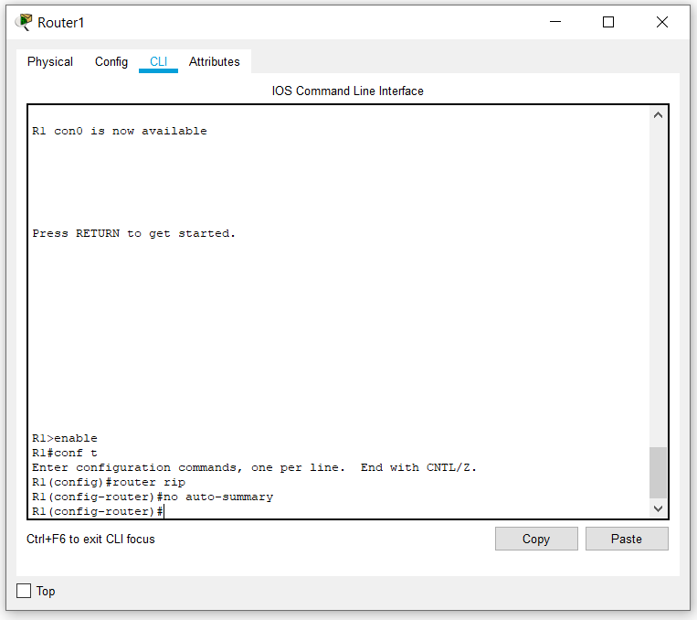

R3(config)#**router rip**

R3(config-router)#**no auto-summary**

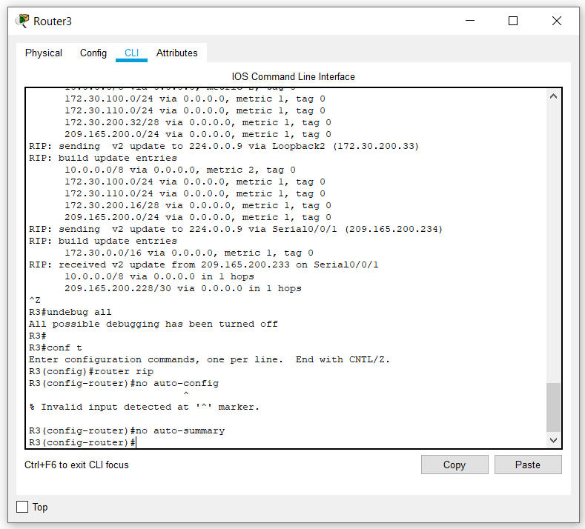

The **show ip route** and **ping** commands can be used to verify that automatic summarization is off.

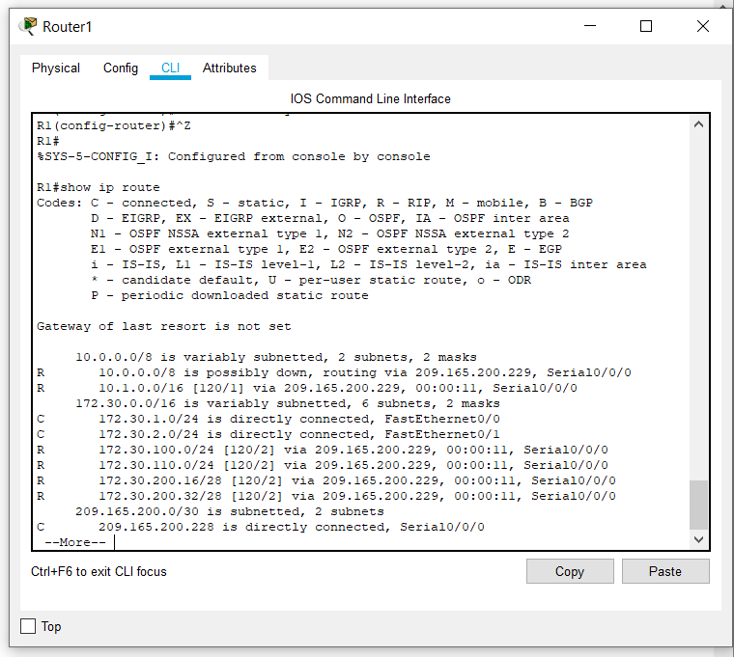

Task 7: Examine the Routing Tables.

The LANs connected to R1 and R3 should now be included in all three routing tables.

R2#**show ip route**

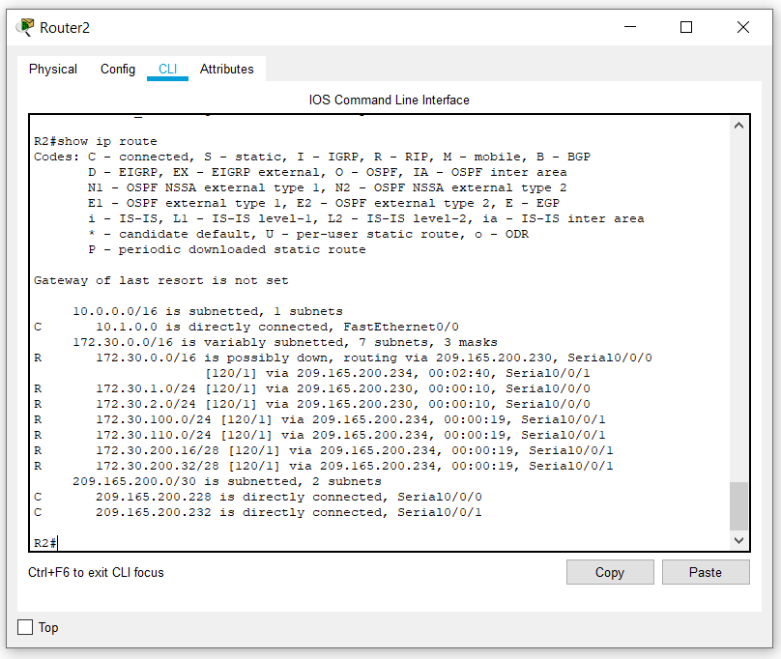

R1#**show ip route**

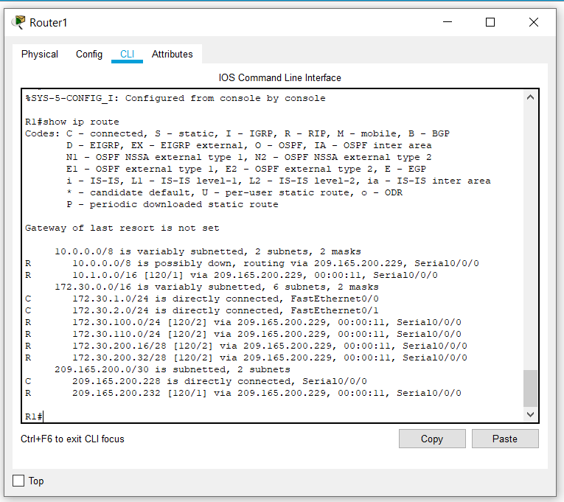

R3#**show ip route**

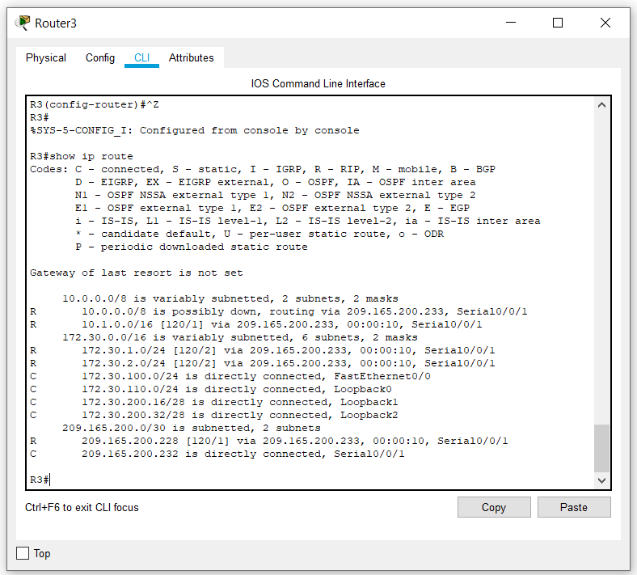

Use the output of the **debug ip rip** command to answer the following questions:

What entries are included in the RIP updates sent out from R1?

172.30.1.0/24 via 0.0.0.0, metric 1, tag 0

172.30.2.0/24 via 0.0.0.0, metric 1, tag 0

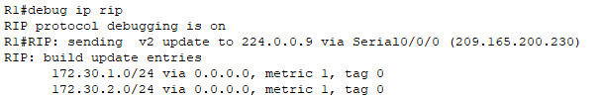

On R2, what routes are in the RIP updates that are received from R1?

172.30.1.0/24 via 0.0.0.0 in 1 hops

172.30.2.0/24 via 0.0.0.0 in 1 hops

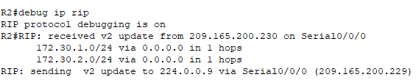

Are the subnet masks now included in the routing updates? NO

Task 8: Verify Network Connectivity.

Step 1: Check connectivity between R2 router and PCs.

From R2, how many ICMP messages are successful when pinging PC1?

**5/5**

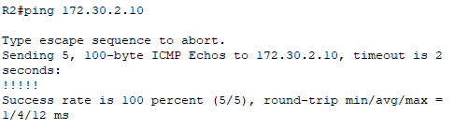

From R2, how many ICMP messages are successful when pinging PC4?

5/5

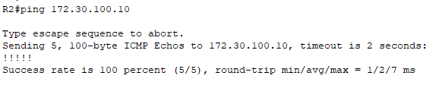

Step 2: Check the connectivity between the PCs.

From PC1, is it possible to ping PC2? YES

What is the success rate? 4/4 100%

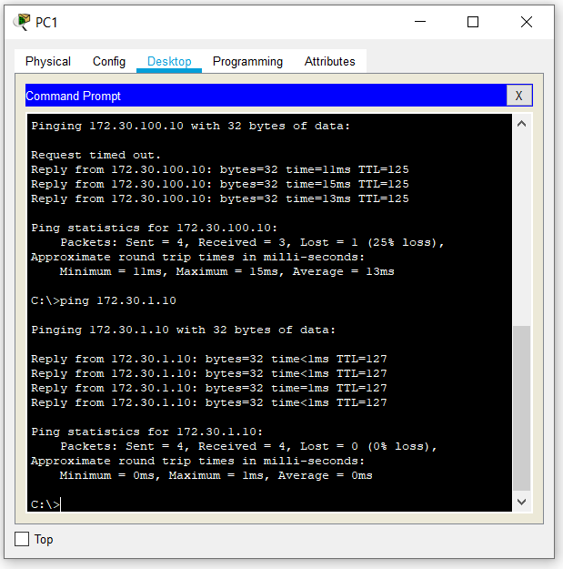

From PC1, is it possible to ping PC3? YES

What is the success rate? 4/4 100%

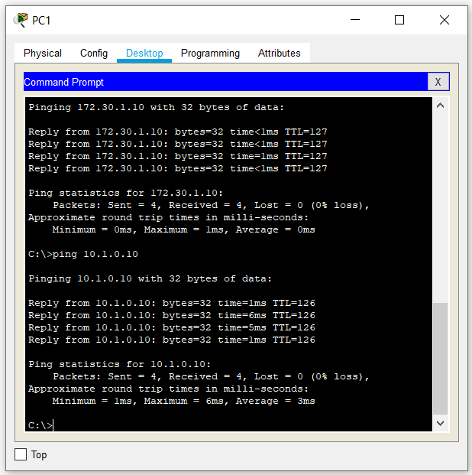

From PC1, is it possible to ping PC4? YES

What is the success rate? 4/4 100%

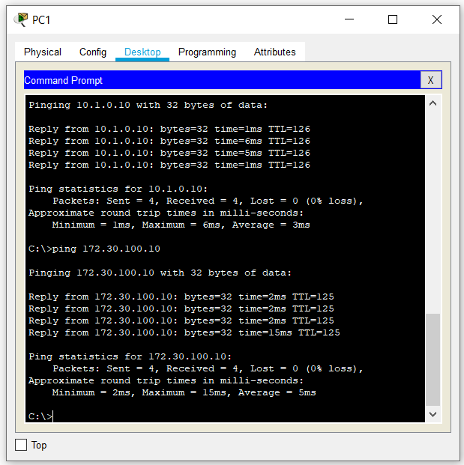

From PC4, is it possible to ping PC2? YES

What is the success rate? 4/4 100%

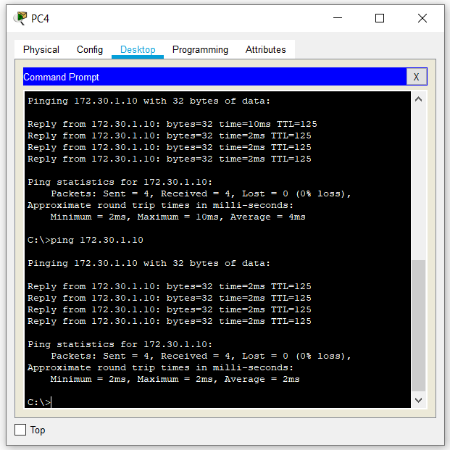

From PC4, is it possible to ping PC3? YES

What is the success rate? 4/4 100%

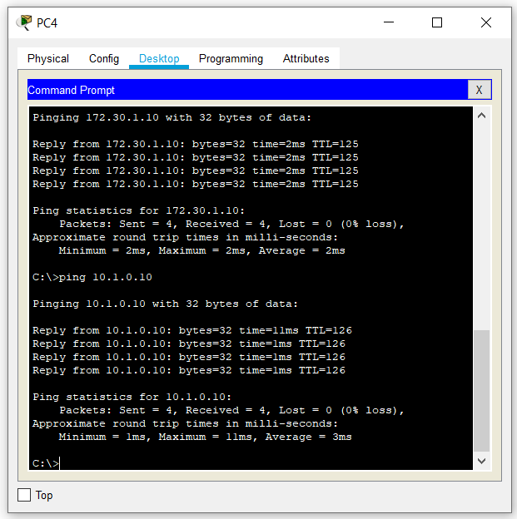

Task 9: Documentation

On each router, capture the following command output to a text (.txt) file and save for future reference.

* **show running-config**

**Router 1**

R1#show running-config

Building configuration...

Current configuration : 885 bytes

!

version 12.4

no service timestamps log datetime msec

no service timestamps debug datetime msec

no service password-encryption

!

hostname R1

!

!

!

!

!

!

!

!

no ip cef

no ipv6 cef

!

!

!

!

!

!

!

!

!

!

!

!

spanning-tree mode pvst

!

!

!

!

!

!

interface FastEthernet0/0

ip address 172.30.1.1 255.255.255.0

duplex auto

speed auto

!

interface FastEthernet0/1

ip address 172.30.2.1 255.255.255.0

duplex auto

speed auto

!

interface Serial0/0/0

ip address 209.165.200.230 255.255.255.252

clock rate 64000

!

interface Serial0/0/1

no ip address

clock rate 2000000

shutdown

!

interface Vlan1

no ip address

shutdown

!

router rip

version 2

passive-interface FastEthernet0/0

passive-interface FastEthernet0/1

network 172.30.0.0

network 209.165.200.0

no auto-summary

!

ip classless

!

ip flow-export version 9

!

!

!

!

!

!

!

!

line con 0

!

line aux 0

!

line vty 0 4

login

!

!

!

end

--More--

**Router 2**

R2#show running-config

Building configuration...

Current configuration : 831 bytes

!

version 12.4

no service timestamps log datetime msec

no service timestamps debug datetime msec

no service password-encryption

!

hostname R2

!

!

!

!

!

!

!

!

no ip cef

no ipv6 cef

!

!

!

!

!

!

!

!

!

!

!

!

spanning-tree mode pvst

!

!

!

!

!

!

interface FastEthernet0/0

ip address 10.1.0.1 255.255.0.0

duplex auto

speed auto

!

interface FastEthernet0/1

no ip address

duplex auto

speed auto

shutdown

!

interface Serial0/0/0

ip address 209.165.200.229 255.255.255.252

!

interface Serial0/0/1

ip address 209.165.200.233 255.255.255.252

clock rate 64000

!

interface Vlan1

no ip address

shutdown

!

router rip

version 2

passive-interface FastEthernet0/0

network 10.0.0.0

network 209.165.200.0

no auto-summary

!

ip classless

!

ip flow-export version 9

!

!

!

!

!

!

!

!

line con 0

!

line aux 0

!

line vty 0 4

login

!

!

!

end

**Router 3**

R3#show running-config

Building configuration...

Current configuration : 1011 bytes

!

version 12.4

no service timestamps log datetime msec

no service timestamps debug datetime msec

no service password-encryption

!

hostname R3

!

!

!

!

!

!

!

!

no ip cef

no ipv6 cef

!

!

!

!

!

!

!

!

!

!

!

!

spanning-tree mode pvst

!

!

!

!

!

!

interface Loopback0

ip address 172.30.110.1 255.255.255.0

!

interface Loopback1

ip address 172.30.200.17 255.255.255.240

!

interface Loopback2

ip address 172.30.200.33 255.255.255.240

!

interface FastEthernet0/0

ip address 172.30.100.1 255.255.255.0

duplex auto

speed auto

!

interface FastEthernet0/1

no ip address

duplex auto

speed auto

shutdown

!

interface Serial0/0/0

no ip address

clock rate 2000000

shutdown

!

interface Serial0/0/1

ip address 209.165.200.234 255.255.255.252

!

interface Vlan1

no ip address

shutdown

!

router rip

version 2

passive-interface FastEthernet0/0

network 172.30.0.0

network 209.165.200.0

no auto-summary

!

ip classless

!

ip flow-export version 9

!

!

!

!

!

!

!

!

line con 0

!

line aux 0

!

line vty 0 4

login

!

!

!

end

* **show ip route**

**Router 1**

R1#show ip route

Codes: C - connected, S - static, I - IGRP, R - RIP, M - mobile, B - BGP

D - EIGRP, EX - EIGRP external, O - OSPF, IA - OSPF inter area

N1 - OSPF NSSA external type 1, N2 - OSPF NSSA external type 2

E1 - OSPF external type 1, E2 - OSPF external type 2, E - EGP

i - IS-IS, L1 - IS-IS level-1, L2 - IS-IS level-2, ia - IS-IS inter area

* - candidate default, U - per-user static route, o - ODR

P - periodic downloaded static route

10.0.0.0/16 is subnetted, 1 subnets

R 10.1.0.0 [120/1] via 209.165.200.229, 00:00:29, Serial0/0/0

172.30.0.0/16 is variably subnetted, 6 subnets, 2 masks

C 172.30.1.0/24 is directly connected, FastEthernet0/0

C 172.30.2.0/24 is directly connected, FastEthernet0/1

R 172.30.100.0/24 [120/2] via 209.165.200.229, 00:00:29, Serial0/0/0

R 172.30.110.0/24 [120/2] via 209.165.200.229, 00:00:29, Serial0/0/0

R 172.30.200.16/28 [120/2] via 209.165.200.229, 00:00:29, Serial0/0/0

R 172.30.200.32/28 [120/2] via 209.165.200.229, 00:00:29, Serial0/0/0

209.165.200.0/30 is subnetted, 2 subnets

C 209.165.200.228 is directly connected, Serial0/0/0

R 209.165.200.232 [120/1] via 209.165.200.229, 00:00:29, Serial0/0/0

**Router 2**

R2#show ip route

Codes: C - connected, S - static, I - IGRP, R - RIP, M - mobile, B - BGP

D - EIGRP, EX - EIGRP external, O - OSPF, IA - OSPF inter area

N1 - OSPF NSSA external type 1, N2 - OSPF NSSA external type 2

E1 - OSPF external type 1, E2 - OSPF external type 2, E - EGP

i - IS-IS, L1 - IS-IS level-1, L2 - IS-IS level-2, ia - IS-IS inter area

* - candidate default, U - per-user static route, o - ODR

P - periodic downloaded static route

10.0.0.0/16 is subnetted, 1 subnets

C 10.1.0.0 is directly connected, FastEthernet0/0

172.30.0.0/16 is variably subnetted, 6 subnets, 2 masks

R 172.30.1.0/24 [120/1] via 209.165.200.230, 00:00:16, Serial0/0/0

R 172.30.2.0/24 [120/1] via 209.165.200.230, 00:00:16, Serial0/0/0

R 172.30.100.0/24 [120/1] via 209.165.200.234, 00:00:25, Serial0/0/1

R 172.30.110.0/24 [120/1] via 209.165.200.234, 00:00:25, Serial0/0/1

R 172.30.200.16/28 [120/1] via 209.165.200.234, 00:00:25, Serial0/0/1

R 172.30.200.32/28 [120/1] via 209.165.200.234, 00:00:25, Serial0/0/1

209.165.200.0/30 is subnetted, 2 subnets

C 209.165.200.228 is directly connected, Serial0/0/0

C 209.165.200.232 is directly connected, Serial0/0/1

R2#

**Router 3**

R3#show ip route

Codes: C - connected, S - static, I - IGRP, R - RIP, M - mobile, B - BGP

D - EIGRP, EX - EIGRP external, O - OSPF, IA - OSPF inter area

N1 - OSPF NSSA external type 1, N2 - OSPF NSSA external type 2

E1 - OSPF external type 1, E2 - OSPF external type 2, E - EGP

i - IS-IS, L1 - IS-IS level-1, L2 - IS-IS level-2, ia - IS-IS inter area

* - candidate default, U - per-user static route, o - ODR

P - periodic downloaded static route

10.0.0.0/16 is subnetted, 1 subnets

R 10.1.0.0 [120/1] via 209.165.200.233, 00:00:04, Serial0/0/1

172.30.0.0/16 is variably subnetted, 6 subnets, 2 masks

R 172.30.1.0/24 [120/2] via 209.165.200.233, 00:00:04, Serial0/0/1

R 172.30.2.0/24 [120/2] via 209.165.200.233, 00:00:04, Serial0/0/1

C 172.30.100.0/24 is directly connected, FastEthernet0/0

C 172.30.110.0/24 is directly connected, Loopback0

C 172.30.200.16/28 is directly connected, Loopback1

C 172.30.200.32/28 is directly connected, Loopback2

209.165.200.0/30 is subnetted, 2 subnets

R 209.165.200.228 [120/1] via 209.165.200.233, 00:00:04, Serial0/0/1

C 209.165.200.232 is directly connected, Serial0/0/1

R3#

* **show ip interface brief**

**Router 1**

R1#show ip interface brief

Interface IP-Address OK? Method Status Protocol

FastEthernet0/0 172.30.1.1 YES manual up up

FastEthernet0/1 172.30.2.1 YES manual up up

Serial0/0/0 209.165.200.230 YES manual up up

Serial0/0/1 unassigned YES unset administratively down down

Vlan1 unassigned YES unset administratively down down

R1#

**Router 2**

R2#show ip interface brief

Interface IP-Address OK? Method Status Protocol

FastEthernet0/0 10.1.0.1 YES manual up up

FastEthernet0/1 unassigned YES unset administratively down down

Serial0/0/0 209.165.200.229 YES manual up up

Serial0/0/1 209.165.200.233 YES manual up up

Vlan1 unassigned YES unset administratively down down

R2#

**Router 3**

R3#show ip interface brief

Interface IP-Address OK? Method Status Protocol

FastEthernet0/0 172.30.100.1 YES manual up up

FastEthernet0/1 unassigned YES unset administratively down down

Serial0/0/0 unassigned YES unset administratively down down

Serial0/0/1 209.165.200.234 YES manual up up

Loopback0 172.30.110.1 YES manual up up

Loopback1 172.30.200.17 YES manual up up

Loopback2 172.30.200.33 YES manual up up

Vlan1 unassigned YES unset administratively down down

R3#

* **show ip protocols**

**Router 1**

R1#show ip protocols

Routing Protocol is "rip"

Sending updates every 30 seconds, next due in 22 seconds

Invalid after 180 seconds, hold down 180, flushed after 240

Outgoing update filter list for all interfaces is not set

Incoming update filter list for all interfaces is not set

Redistributing: rip

Default version control: send version 2, receive 2

Interface Send Recv Triggered RIP Key-chain

Serial0/0/0 2 2

Automatic network summarization is not in effect

Maximum path: 4

Routing for Networks:

172.30.0.0

209.165.200.0

Passive Interface(s):

FastEthernet0/0

FastEthernet0/1

Routing Information Sources:

Gateway Distance Last Update

209.165.200.229 120 00:00:09

Distance: (default is 120)

R1#

**Router 2**

R2#show ip protocols

Routing Protocol is "rip"

Sending updates every 30 seconds, next due in 15 seconds

Invalid after 180 seconds, hold down 180, flushed after 240

Outgoing update filter list for all interfaces is not set

Incoming update filter list for all interfaces is not set

Redistributing: rip

Default version control: send version 2, receive 2

Interface Send Recv Triggered RIP Key-chain

Serial0/0/1 2 2

Serial0/0/0 2 2

Automatic network summarization is not in effect

Maximum path: 4

Routing for Networks:

10.0.0.0

209.165.200.0

Passive Interface(s):

FastEthernet0/0

Routing Information Sources:

Gateway Distance Last Update

209.165.200.230 120 00:00:06

209.165.200.234 120 00:00:21

Distance: (default is 120)

R2#

**Router 3**

R3#show ip protocols

Routing Protocol is "rip"

Sending updates every 30 seconds, next due in 8 seconds

Invalid after 180 seconds, hold down 180, flushed after 240

Outgoing update filter list for all interfaces is not set

Incoming update filter list for all interfaces is not set

Redistributing: rip

Default version control: send version 2, receive 2

Interface Send Recv Triggered RIP Key-chain

Loopback0 2 2

Loopback1 2 2

Loopback2 2 2

Serial0/0/1 2 2

Automatic network summarization is not in effect

Maximum path: 4

Routing for Networks:

172.30.0.0

209.165.200.0

Passive Interface(s):

FastEthernet0/0

Routing Information Sources:

Gateway Distance Last Update

209.165.200.233 120 00:00:09

Distance: (default is 120)

R3#

If you need to review the procedures for capturing command output, refer to Lab 1.5.1.

Task 10: Clean Up

Erase the configurations and reload the routers. Disconnect and store the cabling. For PC hosts that are normally connected to other networks (such as the school LAN or to the Internet), reconnect the appropriate cabling and restore the TCP/IP settings.

